STUDENT DATABASE
MANAGEMENT SYSTEM.

MEMBERS: 1)Rohan Lopes.
2)Smeet Pereira.
3)Nimish Main.

Table of Contents
Description Page No.

1.Introduction.
2.What Front end and Back end.
3.ER Diagram.
4.EER Diagram Relation Schema.
5.Hardware Specification.
6.Schema Design.
7.Evalution of software.
8.Reference of project.
9.Project Snapshot.
10.Code of software.

1.INTRODUCTION
Student Database Management System helps us to give information about any sort of student studying in a praicular institute,as a result of this this system is very important and helpful.
The other important use of this system is that it saves time for finding the info abt a particular student(i.e time efficient system).
In this project we have created three functions such as view,delete and update.View function can be used by the operator only to get info abt a particular student and update and delete function are used by the administrator to update and delete the entries respectively.

FRONT END AND BACK END
OF THE PROJECT.

ER DIAGRAM 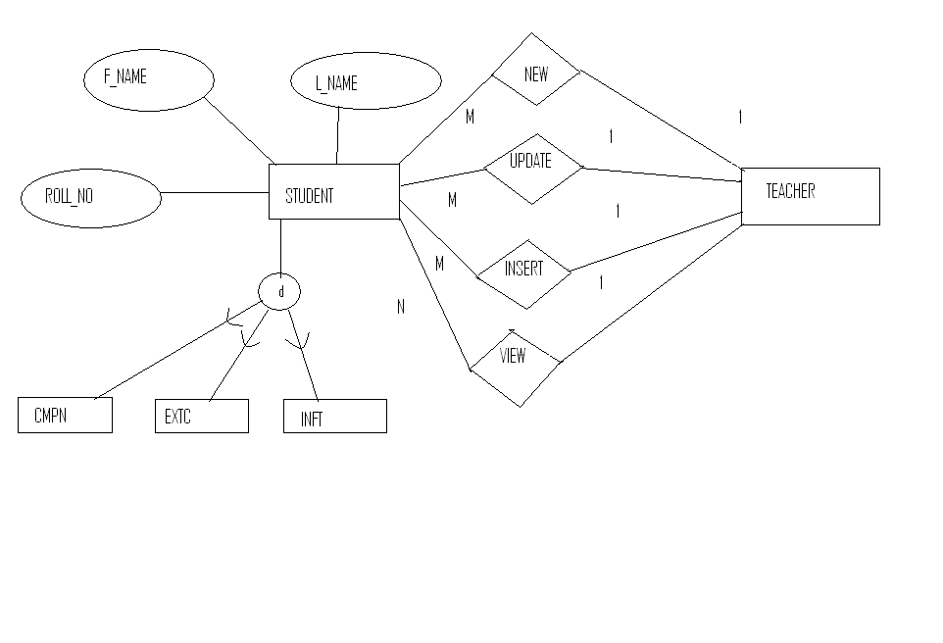

EER DIAGRAM RELATION
SCHEMA

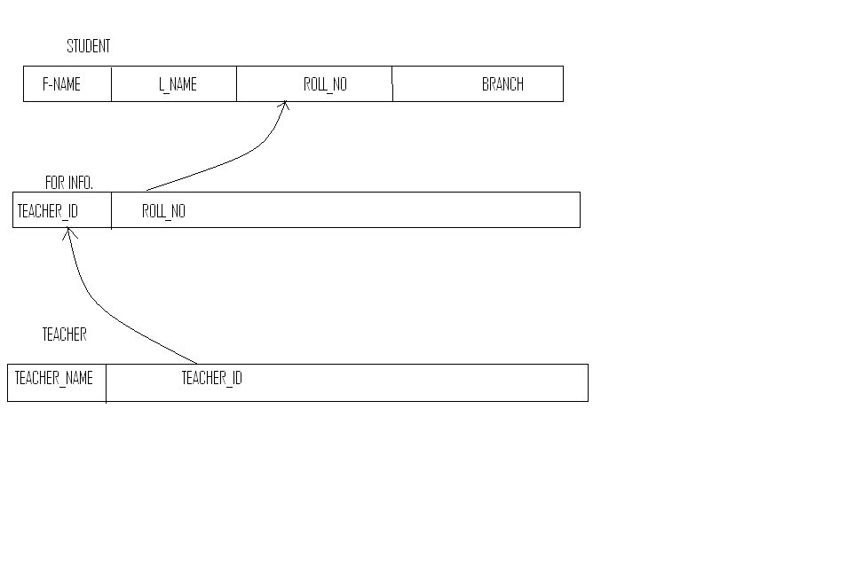

HARDWARE AND SOFTWARE
SPECIFICATION

Definitions, Acronyms, and Abbreviations:
- HTML (Hyper Text Markup Language): It is used to create static web pages.
2.)HTTP (Hyper Text Transfer Protocol): It is a transaction oriented
client/server protocol between a web browser and a web server.
3.) Web 2.0: It is commonly associated with web applications which
facilitate interactive information sharing, interoperability, user-
centered design and collaboration on the World Wide Web.
4.) SQL (Structured Query Language): It is commonly used with a
oracle database for retrieving information from the database.
PURPOSE:
Student Database Management System helps us to give information about any sort of student studying in a praicular institute,as a result of this this system is very important and helpful.
The other important use of this system is that it saves time for finding the info abt a particular student(i.e time efficient system).
If the operator wants to acces the information of a particular student he can jus view the database by using the view function.If a new entry is to be made in the database the admin can update the database using update function and if the entry of a particular student is to be deleted from the database the admin can delete the entry by using delte function.

SCHEMA DESIGN EXPLAIN

EVALUATION OF SOFTWARE

Technologies to be used:
- J2EE: (Servlet, JSP, JAXP, Java Beans) Application architecture.
- JAVA: Application architecture.
- HTML5: Basic web page designing
- XML: Extensible Markup Language.
- JAVASCRIPT
- JQUERRY
- ORACLE 9i : Database

Overview:
The SRS will include two sections, namely:
-I- Overall Description: This section will describe major components of the system, interconnections, and external interfaces.
-I- Specific Requirements: This section will describe the
Functions of actors, their roles in the system and the constraints faced by the system.

Software Interface
The major chunk of all the coding will be based on HTML5 along with JavaScript, CSS for styling in the web pages and some JQuery and JSP techniques also might be used. The back end used will be MS Access / Oracle 9i/ Oracle 11g.

SPECIFIC REQUIREMENTS

These are the basic needs very system needs to fulfill:
- A JavaScript enabled Web Browser.
- Support for Oracle/MS Access database
- ODBC Connectivity, etc.

FUTURE SCOPE:

Login.php file

<body bgcolor="#cdcdcd">
<p align="center">&nbsp;</p><hr>
<div style="background:#cf2255;width:'80%';"
align="center">
<font color="#ffffcc"
size="8pt"><b>Student Database Mngt Sys</b>&copy</font>,v 1.0.3</div>
<hr>
<b>
<br><br><br>
<center><img src="student.png"><br><br><br>
<table border="1" align="center" cellpadding="4" cellspacing="4">
<tr>
<b>
<form name='form' method='post' action='logincheck.php'>
<tr><td>Username :<input type=text name='username'></tr>
<tr><td>Password :<input type=password name=' name'></tr>
<tr><td><input type="submit" name="Login">&nbsp&nbsp&nbsp
<input type="reset" name="Cancel value="Cancel"></center></tr>
</form>

</tr>
</table>

<br><br>

<br><br>
<hr>

LoginCheck.php
<body bgcolor="#cdcdcd">
<p align="center">&nbsp;</p><hr>
<div style="background:#cf2255;width:'80%';"
align="center">
<font color="#ffffcc"
size="8pt"><b>Student Database Mngt Sys</b>&copy</font>,v 1.0.3</div>
<hr>
<b>
<br><br><br><br><br><br>
<?php

$username = $_POST['username'];
$pass = $_POST['name'];

if($username)
{
$connect =mysql_connect("localhost","root","") or die("Couldn't connect MySql!");
mysql_select_db("data") or die("Couldn't find MySql database!");
$query =mysql_query("SELECT * FROM logininfo WHERE username='$username' and password='$pass'");
$numrows =mysql_num_rows($query);
if ($numrows!=0)
{
echo "<center><h3><img src=student.png><br><br><a href=index.php>Click</a>, Here to Continue....";
}
}
else
{
die("please enter Username And Password !!");
}
?>
<br><br><br><br><br>
<hr>

Index.php File
<html>
<body bgcolor="#cdcdcd" >
<p align="center">&nbsp;</p><hr>
<div style="background:#cf2255;width:'80%';"
align="center">
<font color="#ffffcc"
size="8pt"><b>Student Database Mngt Sys</b>&copy</font>,v 1.0.3</div>
<hr><center>
<b>
<br><br><br><h3>Add New Student information Here.</h3><br><br><br><center>
<table border=2>

<form name="form4" action="insert1.php" method="POST">
<tr><td>Rolll No:<td><input type="text" name="rollno"></tr>
<tr><td>PID:<td><input type="text" name="pid"></tr>
<tr><td>First Name:<td><input type="text" name="studentfname"></tr>
<tr><td>Last Name:<td><input type="text" name="studentlfname"></tr>
<tr><td>Class:<td><input type="text" name="class"></tr>
<tr><td>Marks:<td><input type="text" name="marks"></tr></table><br><br>
<input type="submit" name="submit"></tr><br>
</form>
<br><br><br><a href="index.php">Back</a><br><hr>
</html>
Insert1.php

<body bgcolor="#cdcdcd">
<p align="center">&nbsp;</p><hr>
<div style="background:#cf2255;width:'80%';"
align="center">
<font color="#ffffcc"
size="8pt"><b>Student Database Mngt Sys</b>&copy</font>,v 1.0.3</div>
<hr>
<b>
<br><br><br><br><br><br>
<?php

$rollno = $_POST['rollno'];
$pid = $_POST['pid'];
$fname = $_POST['studentfname'];
$lname = $_POST['studentlfname'];
$class = $_POST['class'];
$marks = $_POST['marks'];

if($rollno&&$pid&&$fname&&$lname&&$class&&$marks)
{
$connect =mysql_connect("localhost","root","") or die("Couldn't connect MySql!");
mysql_select_db("data") or die("Couldn't find MySql database!");
$queryreg =mysql_query("INSERT INTO studentinfo VALUES ('$rollno','$pid','$fname','$lname','$class','$marks')");
echo "Record added as name =".$fname;
}
else
{
die("please enter rollno and other details!!");
}
?>
View1.php
<body bgcolor="#cdcdcd" >
<p align="center">&nbsp;</p><hr>
<div style="background:#cf2255;width:'80%';"
align="center">
<font color="#ffffcc"
size="8pt"><b>Student Database Mngt Sys</b>&copy</font>,v 1.0.3</div>
<hr>
<b>
<br><br><br><br><br><br>
<?php

$rollno = $_POST['rollno'];

if($rollno)
{
$connect =mysql_connect("localhost","root","") or die("Couldn't connect MySql!");
mysql_select_db("data") or die("Couldn't find MySql database!");
$query =mysql_query("SELECT * FROM studentinfo WHERE rollno='$rollno'");
$numrows =mysql_num_rows($query);
if ($numrows!=0)
{
while ($row =mysql_fetch_assoc($query))
{
$dbrollno =$row['rollno'];
$dbpid =$row['pid'];
$dbstudentfname =$row['studentfname'];
$dbstudentlname =$row['studentlname'];
$dbclass =$row['class'];
$dbmarks =$row['marks'];
}
if($rollno==$dbrollno)
{

echo "<center><h3>Student Information<hr><h3><br><table border=2><tr><td><b>Roll NO: <td><b>".$dbrollno;
echo "<br></tr><tr><td><b>PID: <td><b>".$dbpid;
echo "<br></tr><tr><td><b>First Name: <td><b>".$dbstudentfname;
echo "<br></tr><tr><td><b>Last Name: <td><b>".$dbstudentlname;
echo "<br></tr><tr><td><b>Class: <td><b>".$dbclass;
echo "<br></tr><tr><td><b>Marks: <td><b>".$dbmarks;
echo "</tr></table>";
}
else
{
echo "Incorrect rollno!";
}
}
}
else
{
die("please enter rollno !!");
}
?>
<br><br>
<a href="index.php">Back</a><br><hr>
Update1.php
<body bgcolor="#cdcdcd" >
<p align="center">&nbsp;</p><hr>
<div style="background:#cf2255;width:'80%';"
align="center">
<font color="#ffffcc"
size="8pt"><b>Student Database Mngt Sys</b>&copy</font>,v 1.0.3</div>
<hr>
<b>
<br><br><br><br><br><br>
<?php

$rollno = $_POST['rollno'];
$pid = $_POST['pid'];
$fname = $_POST['studentfname'];
$lname = $_POST['studentlname'];
$class = $_POST['class'];
$marks = $_POST['marks'];

if($rollno&&$pid&&$fname&&$lname&&$class&&$marks)
{
$connect =mysql_connect("localhost","root","") or die("Couldn't connect MySql!");
mysql_select_db("data") or die("Couldn't find MySql database!");
$queryreg =mysql_query("UPDATE studentinfo SET pid=$pid,studentfname='$fname',studentlname='$lname',class='$class',marks='$marks' WHERE rollno='$rollno'");
echo "Record Updated Successfully for student ".$fname;
}
else
{
die("please enter rollno !!");
}
?>
Delete1.php file

<body bgcolor="#cdcdcd" >
<p align="center">&nbsp;</p><hr>
<div style="background:#cf2255;width:'80%';"
align="center">
<font color="#ffffcc"
size="8pt"><b>Student Database Mngt Sys</b>&copy</font>,v 1.0.3</div>
<hr>
<b>
<br><br><br><br><br><br>
<?php
$rollno = $_POST['rollno'];
if($rollno)
{
$connect =mysql_connect("localhost","root","") or die("Couldn't connect MySql!");
mysql_select_db("data") or die("Couldn't find MySql database!");
$queryreg =mysql_query("DELETE FROM studentinfo WHERE rollno='$rollno'");
echo "Student Record deleted successfully!!";
}
else
{
die("please enter rollno to delete !!");
}
?>

Snapshots Of PROJECT
